**Phone:** 919672747914  
**Email:** jaspayal231198@gmail.com  
**LinkedIn:** Linkedin.com/in/payal-jasoriya-62297b126

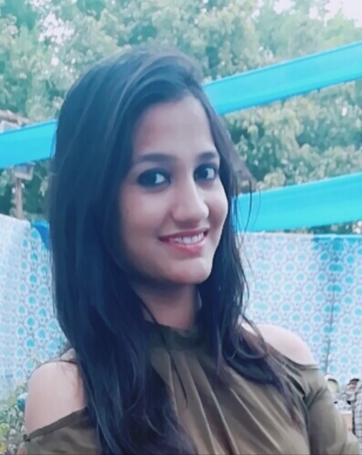

**PAYAL JASORIYA**

**CAREER OBJECTIVE:**

To Frame a carrier that allows me to be compatible in any competitive environment and boots up my capacities, knowledge and energy to their positive full and a drive for self-Improvement with sincerity, dedication and smart work.

**EXPERIENCE:**

|  |  |  |  |
| --- | --- | --- | --- |
| **Year** | **Company** | **Designation** | **Responsibilities** |
|  |  |  |  |
| From 20-MAY-2019 to till date | Tata Consultancy Service | Developer | * Developed solution for middleware interfaces using webmethods. * Developed automation for Business work using VBA. * Working on development of an application as a full Stack Developer |
|  |  |  |  |

**EDUCATION**

|  |  |  |  |
| --- | --- | --- | --- |
| **Year** | **Degree** | **Institute** | **CGPA / Percentage** |
|  |  |  |  |
| 2019 | CSE (Rajasthan Technical University) | NIET | 81% |
| 2015 | XII (Rajasthan board) | Engineer’s Point Sr. Sec. School | 93% |
| 2013 | X (Rajasthan board) | Engineer’s Point Sr. Sec. School | 88.83% |
|  |  |  |  |

**TECHNICAL SKILLS & KNOWLEDGE:**

* Working on Java 8 and React Js.
* Have understanding on Kafka.
* Worked on Webmethods, MFT.
* Worked on Visual Basic Applications.
* Basic knowledge of web designing with HTML and CSS.

**TOOLS:**

* IntelliJ
* Visual Studio Code.
* GitHub.
* Brackets.
* Control-M

**COMPETENCIES**

|  |  |  |
| --- | --- | --- |
| **Behavioral Skill:**   * Team player * Positive attitude * Assertive * Communication | **Personal Traits**:   * Quick Learner * Trustworthiness * Disciplined * Zeal to learn new technology | **Achievements**   * Achieved Best Developer Award by clients. * Achieved Share of Knowledge Award. * Achieved on the Spot Award with TCS Gems. * Achieved Applause Award with TCS Gems |

**EXTRA CURRICULAR ACHIEVEMENTS:**

* Organized welcome party for Clients in TCS
* Organized Tech carol session within Team.
* Winner of intra-college Badminton championship.
* Participated in Fashion Show at college level.
* Co-ordinate and organized various event in college.

**HOBBIES:**

* Watching movies
* Listening to music.

**LANGUAGE KNOWN:**

* Hindi, English

**PERSONAL DETAILS**

Father’s Name: Mr. Hemant Jasoriya Marital Status: Single  
Birthday: November 23, 1998 Nationality: Indian  
Gender: Female

**DECLARATION**

I, Payal Jasoriya, hereby declare that the information contained herein is true and correct to the best of my knowledge and belief.

____________________________  
Payal Jasoriya